Follow the readme.md file.

Download:
https://downloads.graphaware.com/neo4j-the-definitive-guide/neo4j-tdg-chapter5.backup

If you're using the Docker compose provided with this repository, use the following procedure :

1. Move the backup file into the `docker/import` folder of this repository
2. Run the following command :

```bash
docker exec -it -u neo4j neo4j-tdg ./bin/neo4j-admin database restore --from-path=/import/neo4j-tdg-chapter5.backup chapter5

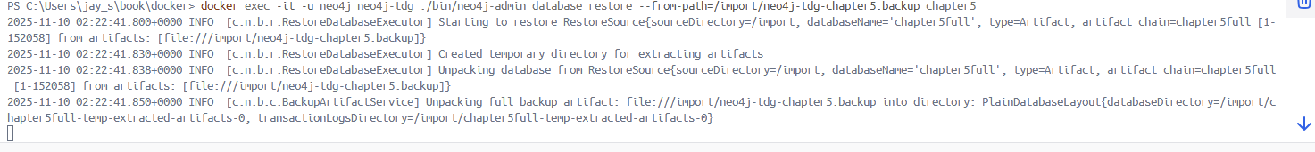

If you press ctlr+C you need to clean them:

1️⃣ Remove any half-restored data inside the container
Run this:
docker exec -it -u neo4j neo4j-tdg rm -rf /data/databases/chapter5
docker exec -it -u neo4j neo4j-tdg rm -rf /data/transactions/chapter5
That deletes any incomplete restore directories.

🔁 2️⃣ Re-run the restore (this time add --overwrite-destination=true)
docker exec -it -u neo4j neo4j-tdg ./bin/neo4j-admin database restore `
--from-path=/import/neo4j-tdg-chapter5.backup chapter5 `
--overwrite-destination=true
- The back-tick (`) lets you wrap a long command on multiple lines in PowerShell.
- This command will start unpacking the backup again — expect several minutes depending on the file size.
👉 Do not press Ctrl + C this time — wait until it prints:
Restore completed successfully

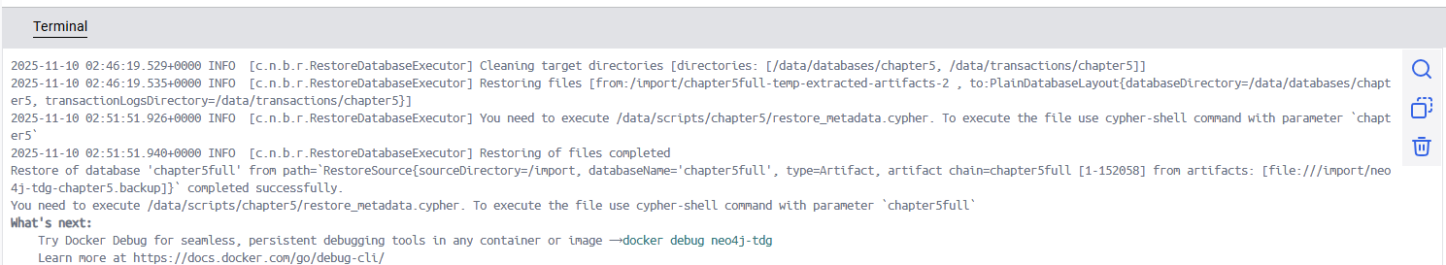

#### Step 3: Create the Database in Neo4j
After restoring the backup, create the `chapter5` database using the Neo4j Browser or Cypher shell:
```cypher
CREATE DATABASE chapter5
```

Now the last step is just to run the Cypher script Neo4j mentioned to restore the database metadata.
Here’s precisely what to do 👇

🧩 Step 1 — Run the restore metadata Cypher script
In PowerShell, execute:
docker exec -it -u neo4j neo4j-tdg cypher-shell -u neo4j -p <your-password> -d chapter5 -f /data/scripts/chapter5/restore_metadata.cypher
🔹 Replace <your-password> with your real Neo4j password (the one you use for neo4j user).
🔹 This command tells Neo4j to execute the file /data/scripts/chapter5/restore_metadata.cypher inside the container, for the restored database named chapter5full.

docker exec -it -u neo4j neo4j-tdg cypher-shell -u neo4j -p password -d chapter5 -f /data/scripts/chapter5/restore_metadata.cypher

docker exec -it -u neo4j neo4j-tdg cypher-shell -u neo4j -p "password" -d chapter5 -f /data/scripts/chapter5/restore_metadata.cypher

docker exec -it -u neo4j neo4j-tdg cypher-shell -u neo4j -p "password" -f /data/scripts/chapter5/restore_metadata.cypher --database chapter5

docker exec -i -u neo4j neo4j-tdg bash -c 'cypher-shell -u neo4j -p "password" --database=chapter5 -f /data/scripts/chapter5/restore_metadata.cypher'

🧩 Step 2 — Confirm the database is registered and online
After that completes, check:
docker exec -it neo4j-tdg cypher-shell -u neo4j -p <your-password> "SHOW DATABASES"
You should see something like:
+----------------+-----------+----------+----------+
| name | role | status | default |
+----------------+-----------+----------+----------+
| neo4j | primary | online | true |
| chapter5full | primary | online | false |
+----------------+-----------+----------+----------+
✅ That means your restored database (chapter5full) is ready to use!

🧩 Step 3 (optional) — Make it the default database
If you want to make chapter5 your default, open:
conf/neo4j.conf
and set:
server.databases.default_to=chapter5
Then restart the container:
docker restart neo4j-tdg

✅ 3️⃣ Verify the database
After it completes:
docker exec -it neo4j-tdg cypher-shell -u neo4j -p <your-password> "SHOW DATABASES"
You should see chapter5 listed with status online.

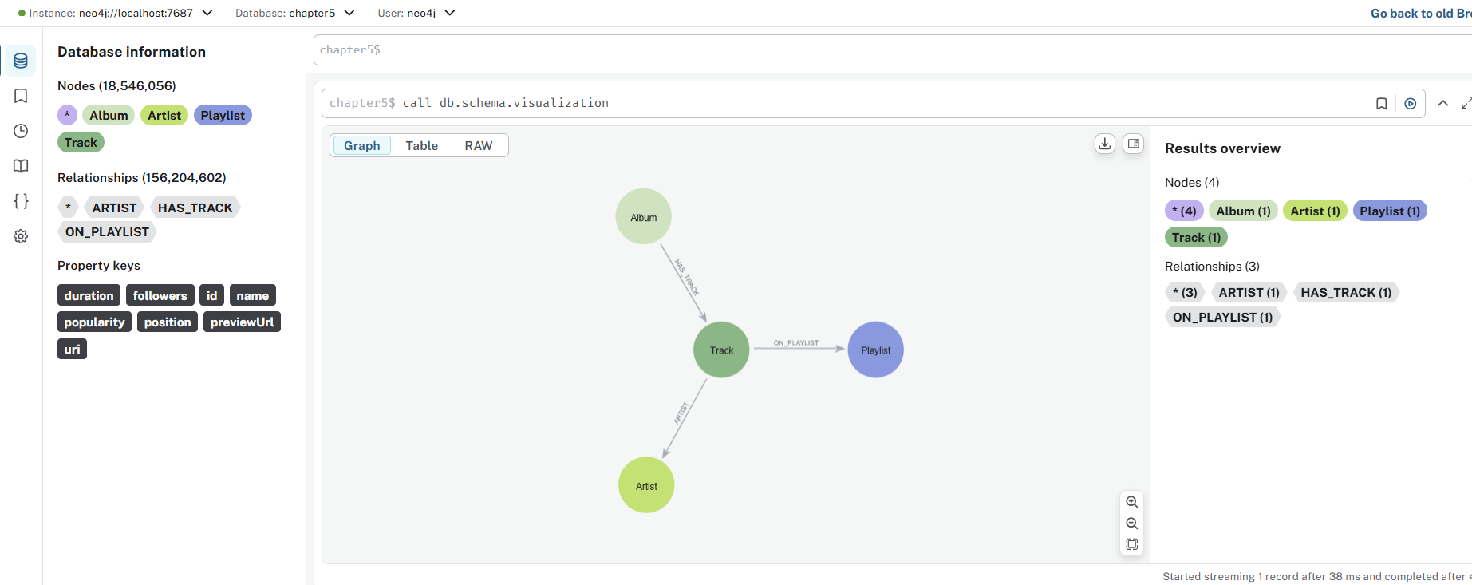

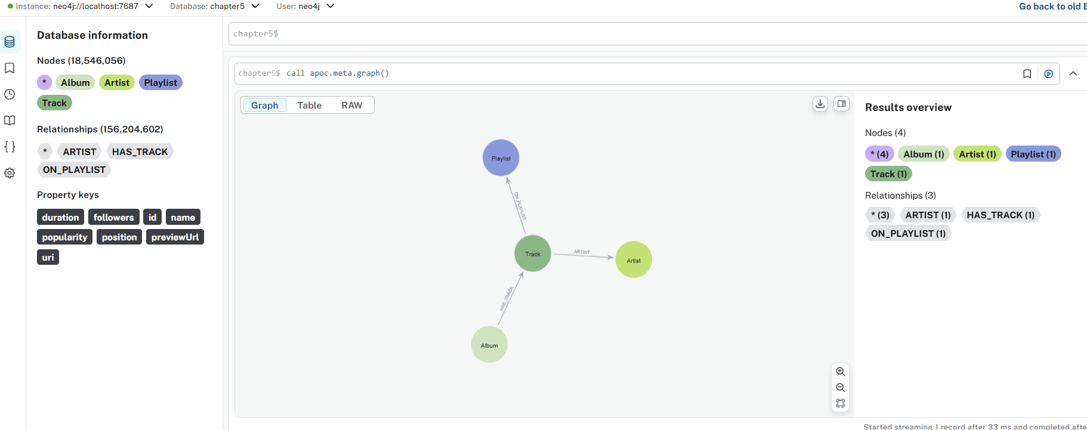

001-explain-global

chapter5$
EXPLAIN MATCH (n)
RETURN n
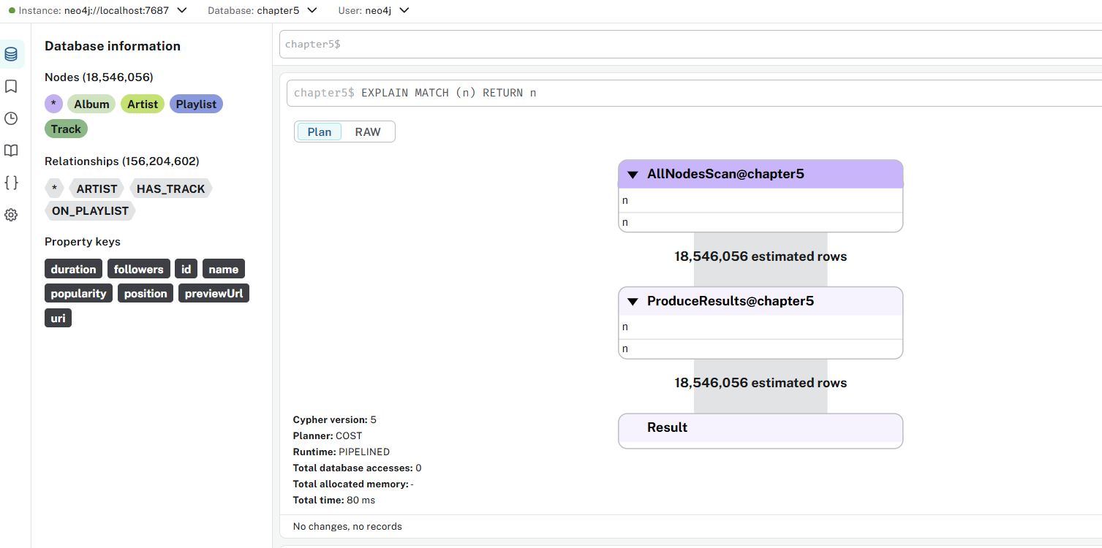

This EXPLAIN plan reveals a full database scan - one of the most expensive operations in Neo4j.

For different database sizes:
- Small DB (1,000 nodes): ~1,000 rows returned
- Medium DB (100,000 nodes): ~100,000 rows returned
- Large DB (10M nodes): ~10,000,000 rows returned

Consequences:
- High memory usage - loads all nodes into memory
- Network overload - transfers massive amounts of data
- Client crashes - most clients can't handle millions of nodes
- Database strain - blocks other operations during scan

002-explain-tonight

chapter5$
EXPLAIN
MATCH (t:Track {name:"Tonight"})-[:ARTIST]->(a:Artist)
RETURN a.name

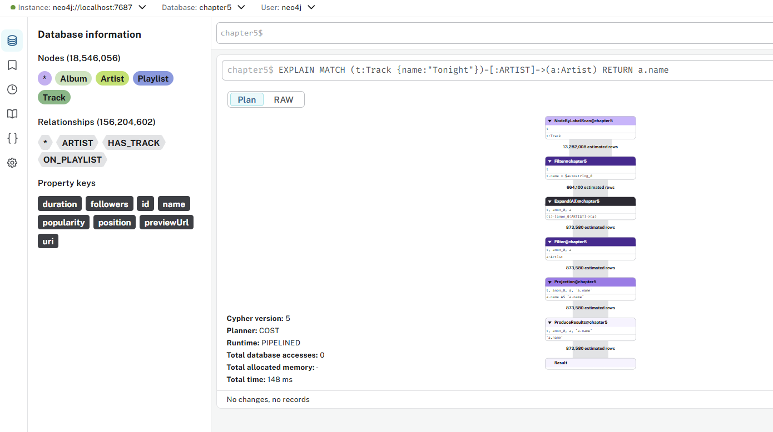

This EXPLAIN plan shows a well-optimized query.

Expected Performance Characteristics
- Consistent execution time regardless of database size
- Minimal memory footprint - only processes relevant data
- Scalable - performance doesn't degrade as more tracks/artists are added

003-profile-tonight

chapter5$
PROFILE
MATCH (t:Track {name:"Tonight"})-[:ARTIST]->(a:Artist)
RETURN a.name

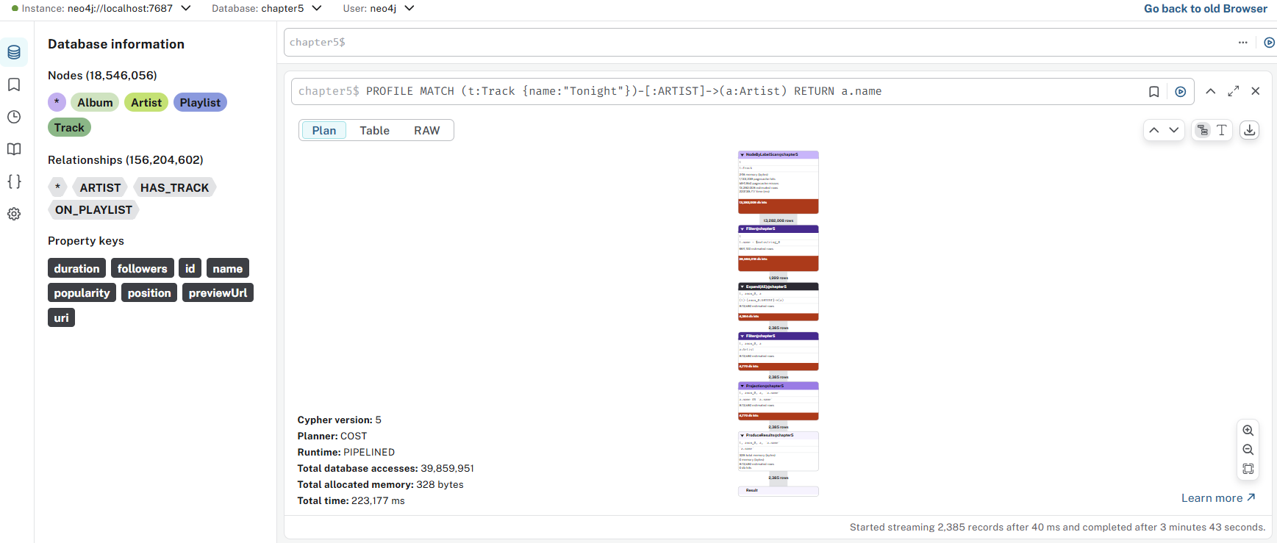

What This Query Does
Finds the artist(s) for a specific track named "Tonight". This PROFILE query is actually well-written and efficient.

Performance Characteristics
- Low DB Hits: Only touches relevant nodes/relationships
- Fast Execution: Index seek + targeted expansion
- Scalable: Performance stays consistent as database grows
- Predictable: Same performance for any track name

What PROFILE Does in Neo4j?
When you prefix a Cypher query with PROFILE, Neo4j:
- Executes your query fully (unlike EXPLAIN, which only simulates it).
- Collects performance data for every step in the execution plan.
- Shows you a detailed breakdown of how the query ran — including:
  - Which indexes or scans were used
  - How many rows each step processed
  - How many database hits occurred
  - Where time and resources were spent

🧩 Example
PROFILE
MATCH (t:Track {name:"Tonight"})-[:ARTIST]->(a:Artist)
RETURN a.name

When you run that, Neo4j will display an execution plan table with something like this:
Operator | Rows | DB Hits | Identifiers
ProduceResults | 1 | 0 | a.name
Expand(All) | 1 | 2 | t, a
NodeIndexSeek | 1 | 1 | t

📊 Meaning of the Columns
- Operator → the step Neo4j performed (e.g., NodeIndexSeek, Expand, Filter, ProduceResults).
- Rows → how many records came out of that step.
- DB Hits → how many low-level reads/writes Neo4j made.
- Page Cache hits/misses (optional, in browser) → shows if data came from memory or disk.

⚡ Why It’s Useful
You use PROFILE to:
- Diagnose slow queries
- Verify index usage
- Compare performance before and after adding constraints or refactoring your query

🧠 Quick Tip
- Use EXPLAIN when you just want to preview the plan (no data fetched).
- Use PROFILE when you want real execution stats.

004-explain-disconnected

chapter5$
EXPLAIN
MATCH (a:Artist),(t:Track)
RETURN a, t

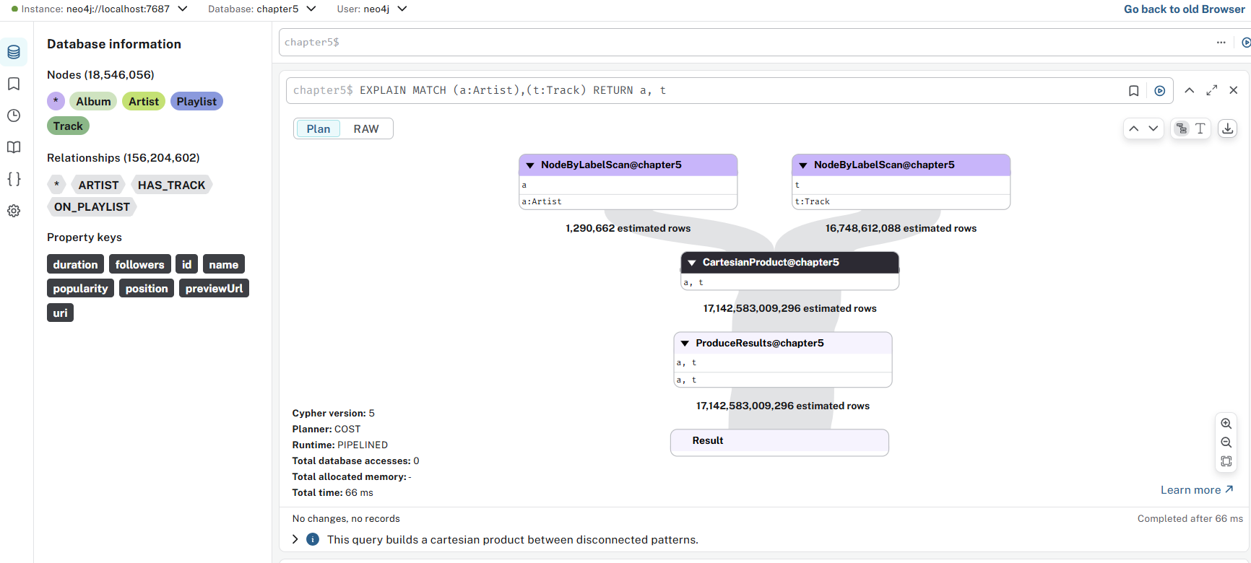

What This Query Actually Does
This creates a cartesian product (cross join) between ALL artists and ALL tracks:
- If you have 1,000 artists and 10,000 tracks
- You get 10,000,000 rows (1,000 × 10,000)
- Each artist is paired with EVERY track

For a medium-sized database:
- 1,000 artists × 10,000 tracks = 10 million rows
- 5,000 artists × 50,000 tracks = 250 million rows

Consequences:
- Memory exhaustion - can crash your database
- Query timeout - may never complete
- Network overload - huge result transfer
- Client crashes - browsers/apps can't handle millions of rows

Legitimate Use Cases (Rare)
The ONLY times this pattern makes sense:
- Tiny datasets (e.g., 10 artists × 20 tracks = 200 rows)
- Cross-join for generating test data
- Specific analytical queries with immediate filtering

005-disconnected-collect

chapter5$
EXPLAIN
MATCH (a:Artist)
WITH COLLECT(a) as artists
MATCH (t:Track)
WITH artists, COLLECT(t) as tracks
RETURN artists,tracks

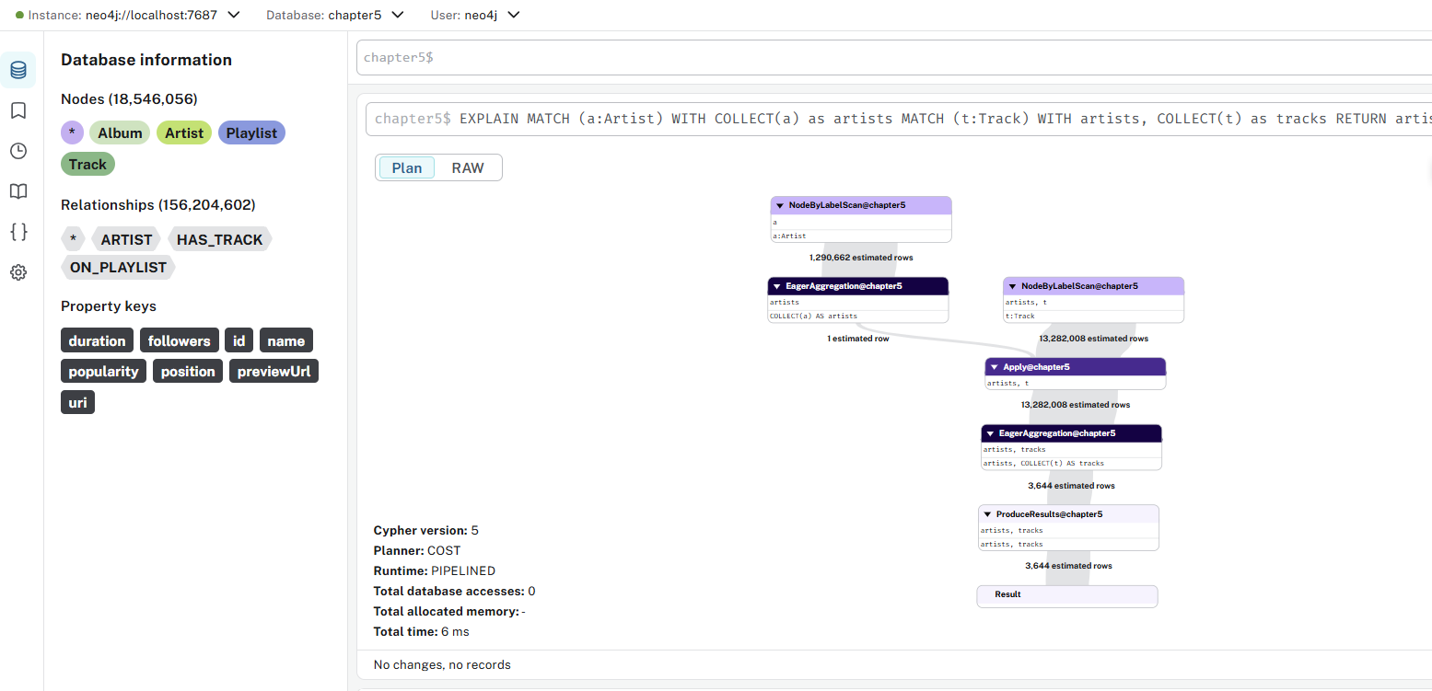

This EXPLAIN plan shows a query that will collect ALL artists and ALL tracks in your database.

- Returns exactly ONE row containing:
  - artists: List of all Artist nodes
  - tracks: List of all Track nodes

What This Query Does
- Finds all Artist nodes and collects them into a single list
- Finds all Track nodes and collects them into a single list
- Returns both giant lists in one row

Memory Explosion:
- If you have 10,000 artists and 100,000 tracks, you're creating:
  - One list with 10,000 node references
  - One list with 100,000 node references
  - In a SINGLE row

Client-Side Crash Risk:
- Most clients (browsers, applications) cannot handle giant lists
- Could crash your Neo4j Browser, application, or driver

No Practical Use Case:
- Returning all data like this is rarely useful
- Usually you want to process, filter, or analyze the data

006-disconnected-tracks

chapter5$
EXPLAIN
MATCH (t:Track)
WITH COLLECT(t) as tracks
MATCH (a:Artist)
WITH tracks, COLLECT(a) as artists
RETURN artists,tracks

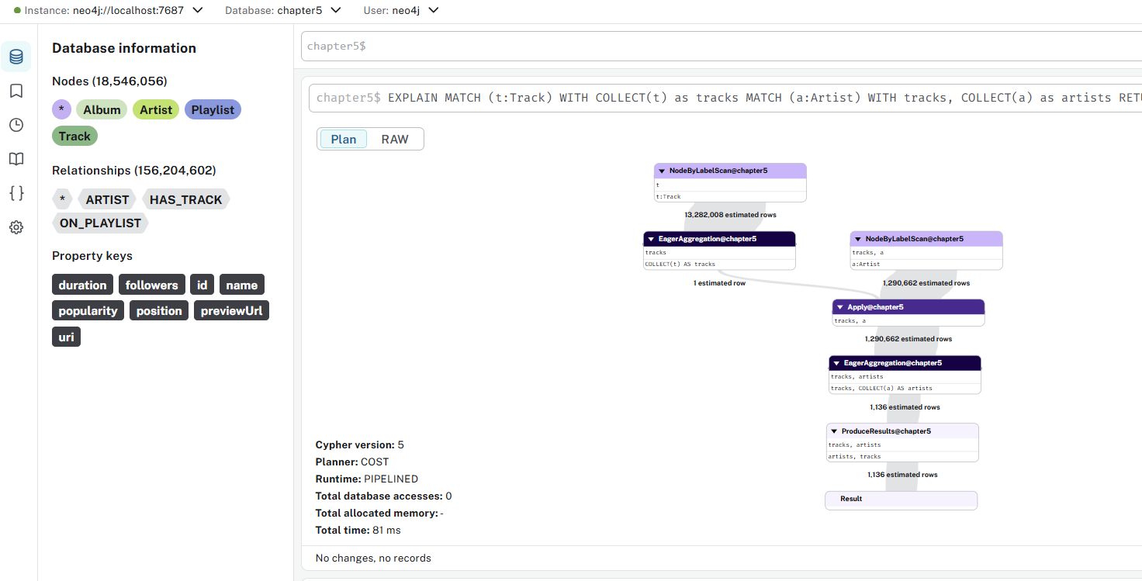

This EXPLAIN plan shows a memory-intensive collection pattern that could be problematic.
- Returns exactly ONE row containing:
  - artists: List of ALL Artist nodes
  - tracks: List of ALL Track nodes

Memory Usage Example:
- 50,000 Track nodes + 10,000 Artist nodes
- Creates two giant in-memory collections
- Single row with 60,000 node references
- All loaded into memory simultaneously

Consequences:
- Heap memory pressure - can cause GC issues
- Client-side crashes - most clients can't handle giant lists
- Network overhead - massive serialization/deserialization
- Blocking operation - during collection phase

What Makes This Different from Cartesian Product
Unlike MATCH (a:Artist), (t:Track) which creates N×M rows, this:
- Creates only 1 row
- But that row contains two massive collections
- Memory usage is O(N + M) instead of O(N × M)

Legitimate Use Cases (Limited)
This pattern might make sense for:
- In-memory processing within a larger query:
MATCH (t:Track) WITH COLLECT(t) as tracks
MATCH (a:Artist) WITH tracks, COLLECT(a) as artists
UNWIND tracks as track
UNWIND artists as artist
// ... some cross-processing logic
- Data export preparation with batching
- Small test databases with few nodes

🔁 What UNWIND Does in Neo4j
UNWIND takes a list (array) and turns it into individual rows in the query result stream.
You can think of it as the opposite of COLLECT().

🧩 Example
WITH [1, 2, 3] AS numbers
UNWIND numbers AS n
RETURN n
Result:
n
1
2
3
So instead of keeping [1,2,3] as one list, UNWIND splits it into 3 separate rows.

Relationship to Your Query
Your query:
MATCH (t:Track)
WITH COLLECT(t) AS tracks
MATCH (a:Artist)
WITH tracks, COLLECT(a) AS artists
UNWIND tracks AS track
UNWIND artists AS artist
Step-by-step meaning:
- MATCH (t:Track) → get all Track nodes.
- WITH COLLECT(t) AS tracks → gather them into a list called tracks.
- MATCH (a:Artist) → get all Artist nodes.
- WITH tracks, COLLECT(a) AS artists → gather them into a list called artists.
- UNWIND tracks AS track → expand the list of tracks into individual rows again.
- UNWIND artists AS artist → then for each track row, expand all artists into rows too.
→ Result: a cartesian product of every track with every artist.
🧠 Conceptually:
Step | What happens
COLLECT() | combines many rows into a list
UNWIND | expands one list back into multiple rows

🧩 Visual Summary
COLLECT: A + B + C → [A,B,C]
UNWIND: [A,B,C] → A
B
C

⚠️ Tip
Be careful:
When you UNWIND multiple lists (like tracks and artists), you can easily create a Cartesian explosion (e.g., 100 tracks × 50 artists = 5000 rows).
So always ensure you actually need that combination or filter it.

007-selective-1

chapter5$
EXPLAIN
MATCH (a:Artist)<-[:ARTIST]-(:Track)-[:ON_PLAYLIST]->(p:Playlist)
RETURN a.name AS artistName, count(p) as playlistCount

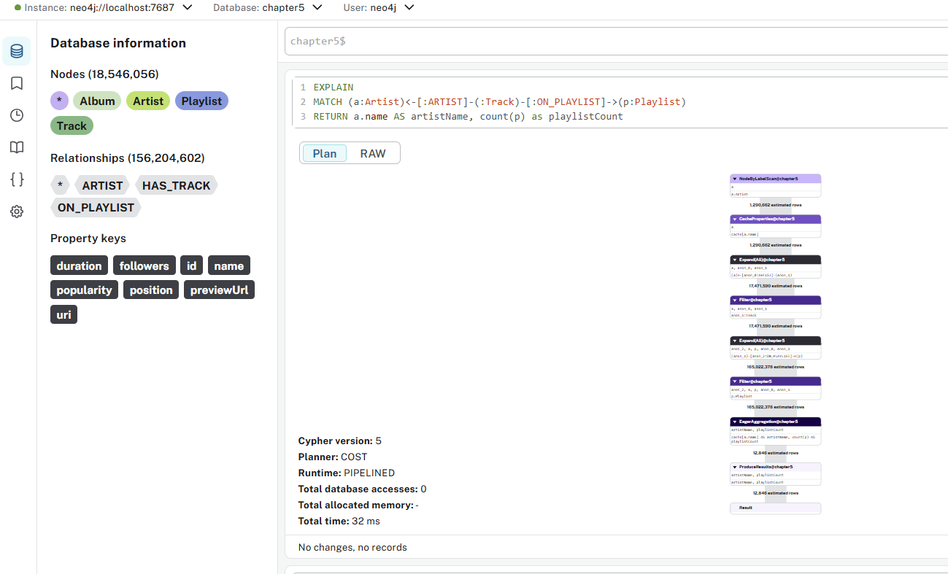

008-selective-2

chapter5$
PROFILE
MATCH (a:Artist)<-[:ARTIST]-()-[:ON_PLAYLIST]->(p)
RETURN a.name AS artistName, count(p) as playlistCount

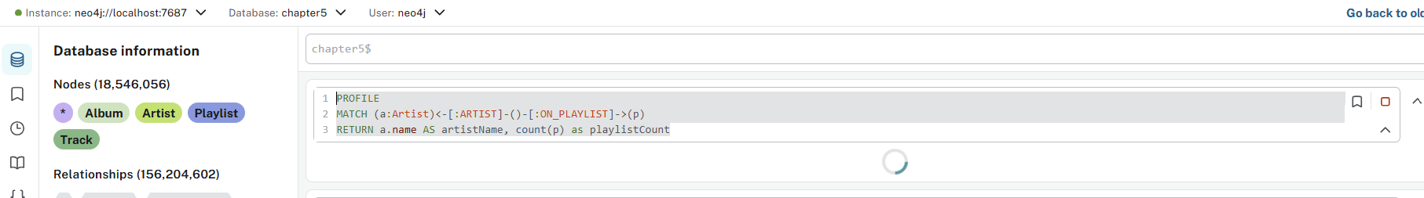

🧩 What That Message Means
When you run a query with PROFILE, Neo4j:
- Executes the query internally.
- Collects performance statistics as rows are produced.
- Only materializes (finalizes) those stats after the query results have been fully iterated over.
So if you run a PROFILE query in a driver (like Neo4j Browser, Neo4j Desktop, or Neo4j Aura console) and don’t actually read all rows, you get that message.
Neo4j is basically saying:
“You haven’t read all the rows yet, so I haven’t finalized the profiling metrics.”

⚙️ How to Fix / See the Full PROFILE Output
✅ Option 1 – Run in Neo4j Browser (Recommended)
Run your query directly in the Neo4j Browser query editor:
PROFILE
MATCH (a:Artist)<-[:ARTIST]-()-[:ON_PLAYLIST]->(p)
RETURN a.name AS artistName, count(p) AS playlistCount
→ Then scroll down to the Execution Plan tab — that’s where the full PROFILE output appears visually.

✅ Option 2 – If You’re Using a Driver or API
If you’re executing the query in code (Node.js, Python, etc.), make sure to iterate through all records:
const result = await session.run(`
PROFILE
MATCH (a:Artist)<-[:ARTIST]-()-[:ON_PLAYLIST]->(p)
RETURN a.name AS artistName, count(p) AS playlistCount
`);

for (const record of result.records) {
console.log(record.get('artistName'), record.get('playlistCount'));
}
Only after iteration will Neo4j complete and materialize the profiler statistics.

✅ Option 3 – Use EXPLAIN Instead
If you just want to see the plan structure without running it:
EXPLAIN
MATCH (a:Artist)<-[:ARTIST]-()-[:ON_PLAYLIST]->(p)
RETURN a.name AS artistName, count(p) AS playlistCount
EXPLAIN always works without needing to iterate, because it doesn’t execute the query.

🧠 TL;DR
- That message = “You haven’t fetched all results yet.”
- Run PROFILE directly in Neo4j Browser, or fetch all records in code.
- It’s not a bug — just how Neo4j handles profiling data.

009-selective-3

chapter5$
EXPLAIN
MATCH (a:Artist)<-[:ARTIST]-()-[:ON_PLAYLIST]->(p)
WHERE p.followers > 5000
RETURN a.name AS artistName, count(p) as playlistCount

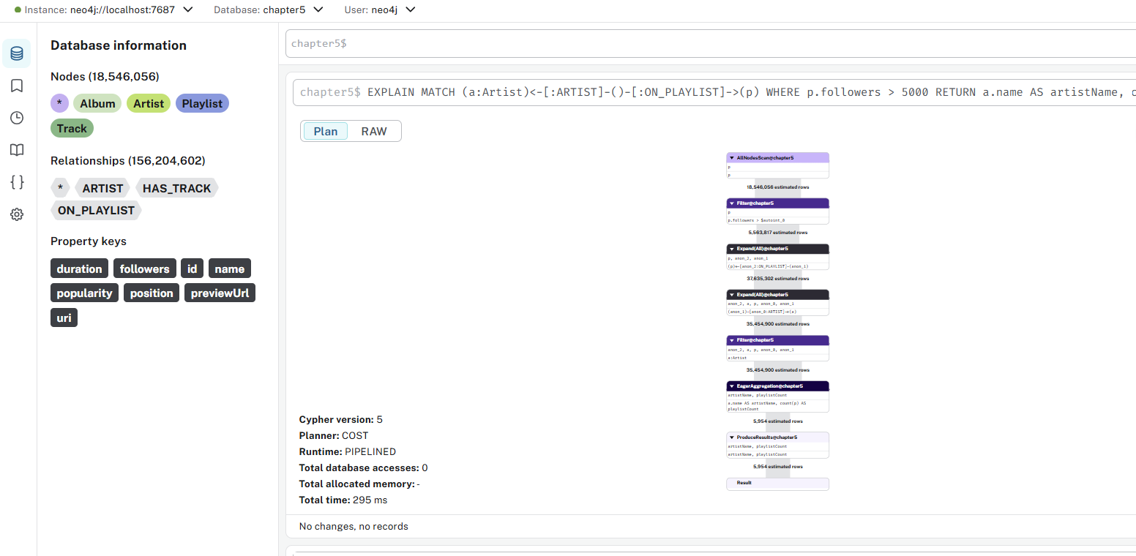

010-selective-4

chapter5$
EXPLAIN
MATCH (a:Artist)<-[:ARTIST]-()-[:ON_PLAYLIST]->(p:Playlist)
WHERE p.followers > 5000
RETURN a.name AS artistName, count(p) as playlistCount

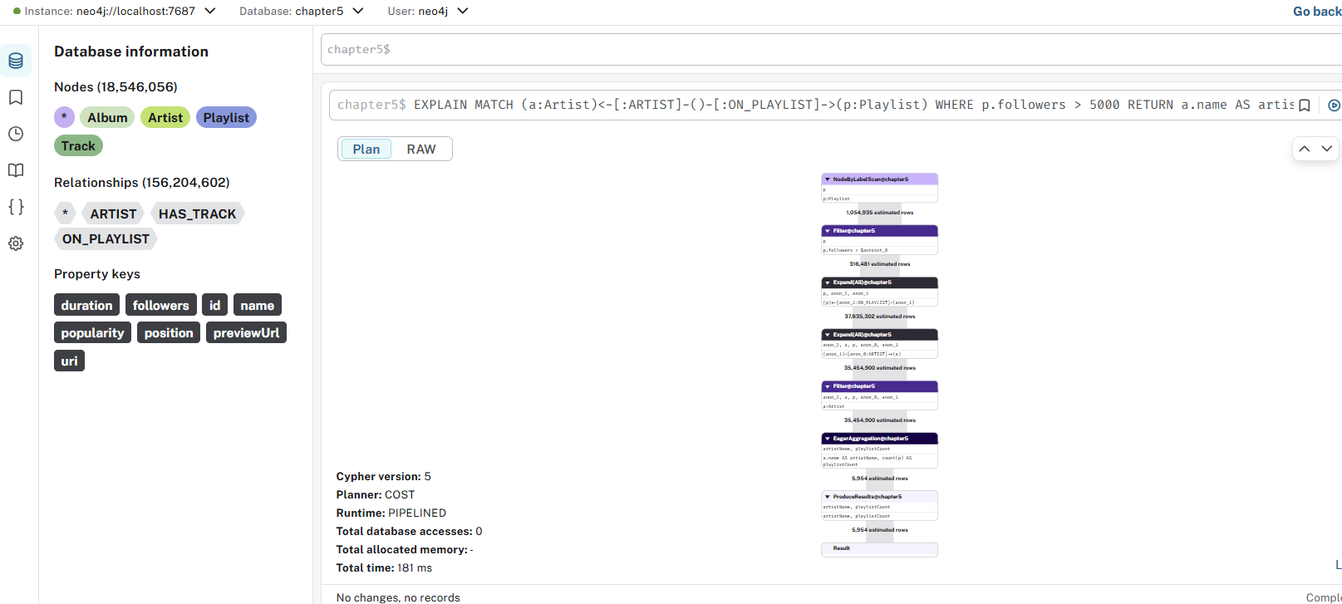

011-selective-index-1

chapter5$
CREATE INDEX playlist_followers_range FOR (n:Playlist) ON (n.followers)

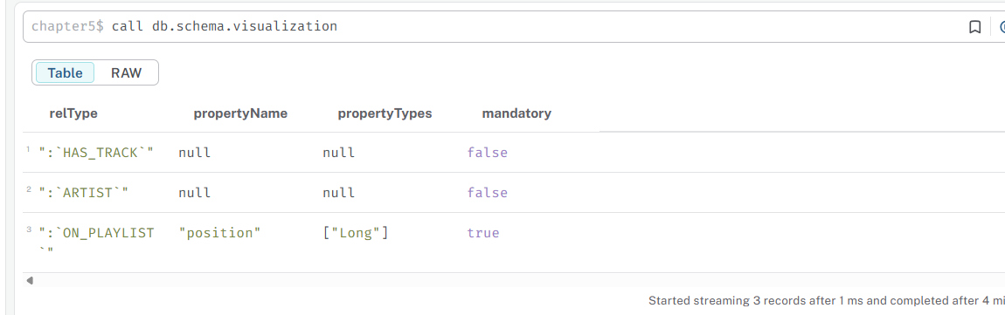
012-selective-index-2

chapter5$
CREATE INDEX playlist_name_range FOR (n:Playlist) ON (n.name)

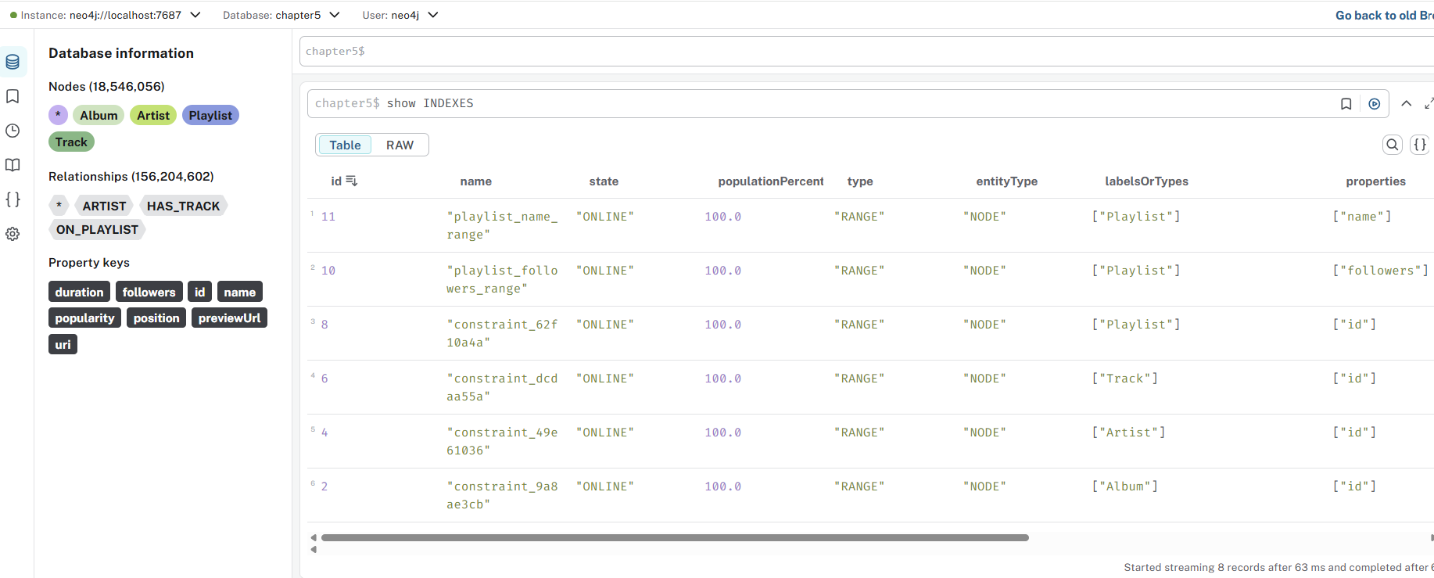

013-selective-5

chapter5$
PROFILE
MATCH (n:Playlist)
WHERE n.followers > 5000 AND n.name STARTS WITH "Sound"
RETURN n

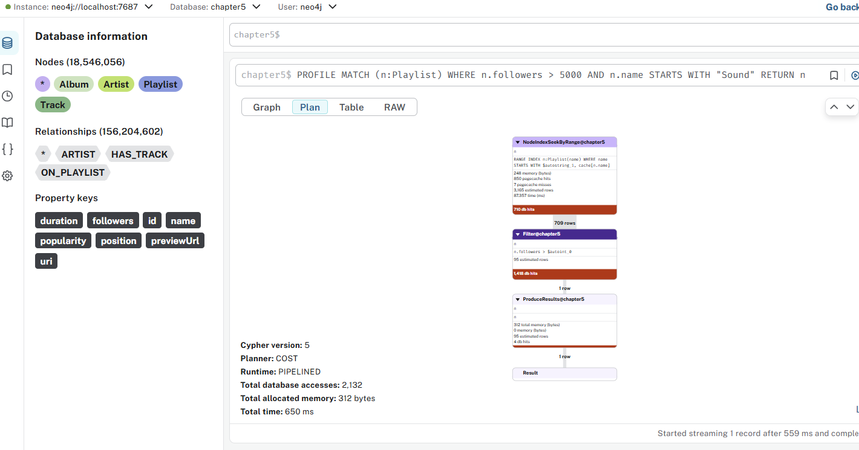

014-selective-6

chapter5$
PROFILE
MATCH (n:Playlist)
WHERE n.followers = 5574 AND n.name STARTS WITH "Sound"
RETURN n

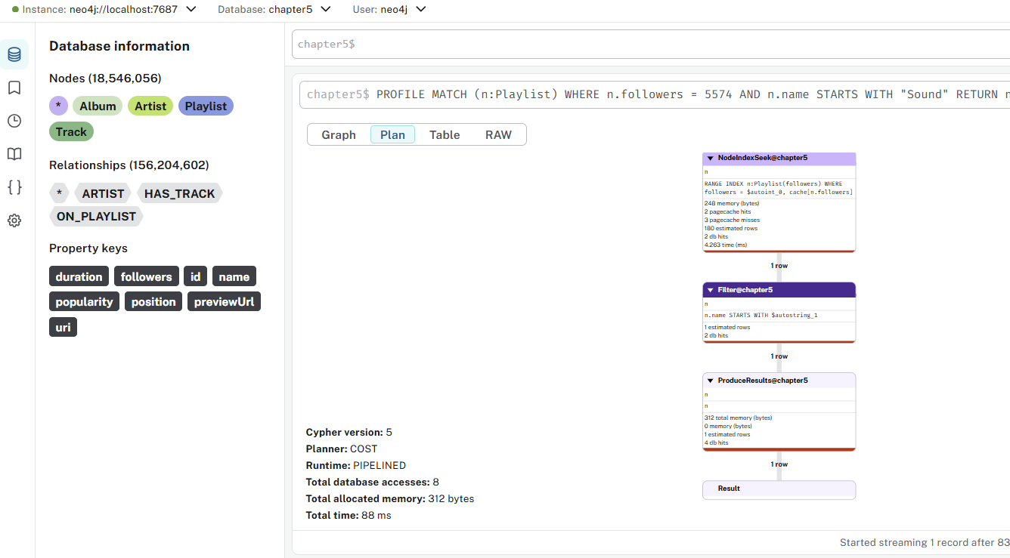

015-selective-index-3

chapter5$
CREATE INDEX playlist_name_followers_range FOR (n:Playlist) ON (n.name,n.followers)

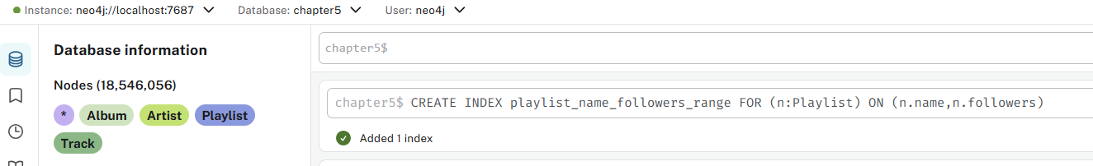

016-access-1

chapter5$
EXPLAIN
MATCH (a:Artist)<-[:ARTIST]-(t:Track)
RETURN a.name, count(t) as trackCount
ORDER by trackCount DESC
LIMIT 10;
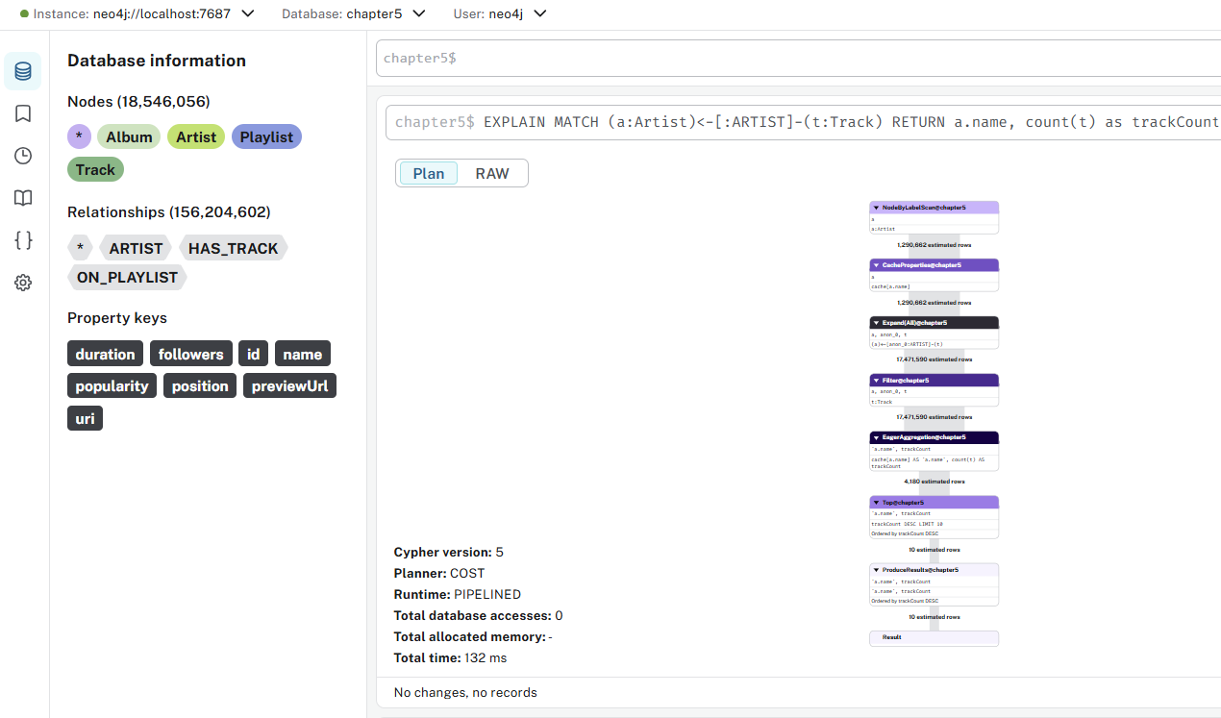

017-access-2

chapter5$
EXPLAIN MATCH (a:Artist)<-[:ARTIST]-(t:Track)
WITH a, count(t) as trackCount
ORDER by trackCount DESC
LIMIT 10
RETURN a.name, trackCount

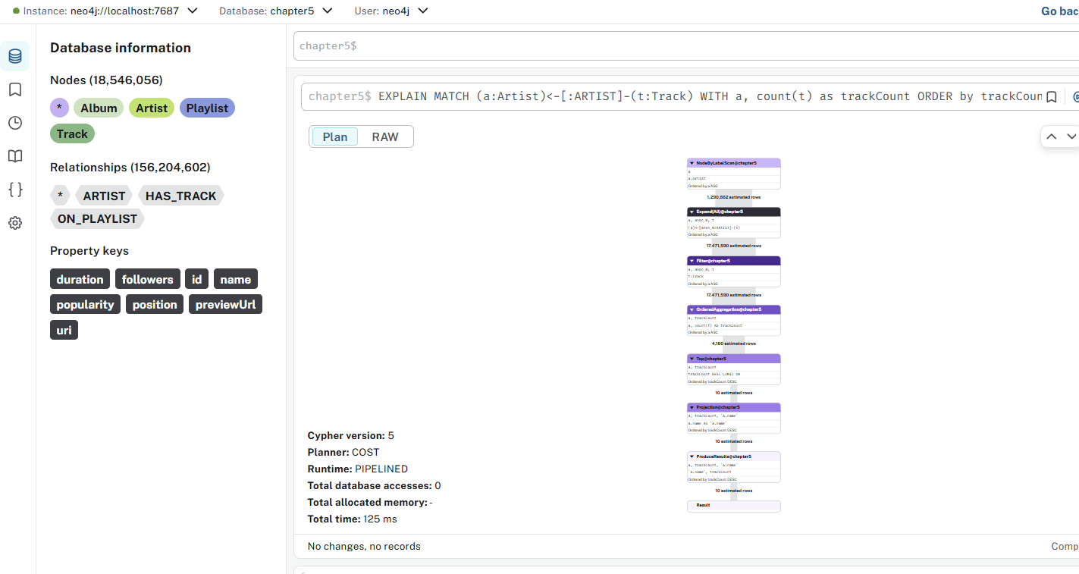

018-degrees-1

chapter5$
PROFILE
MATCH (t:Track)-[:ON_PLAYLIST]->(p)
WITH t, count(p) as playlistCount
WHERE playlistCount > 2500
RETURN t.name

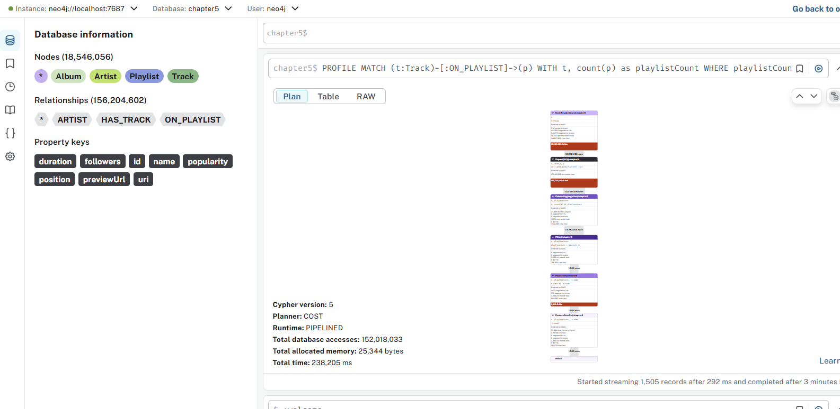

1️⃣ MATCH (t:Track)-[:ON_PLAYLIST]->(p)
- Neo4j starts by matching every Track node, then traversing to all Playlists connected by the ON_PLAYLIST relationship.
- This can explode combinatorially if there are thousands of tracks and each appears in multiple playlists.
- Example: 10,000 tracks × 500 playlists each = 5 million relationship rows.
2️⃣ WITH t, count(p) as playlistCount
- Neo4j must aggregate all matches for each Track before moving on.
- That means it must scan and group potentially millions of rows before it can compute count(p) for each track.
- It cannot use indexes here — this is a full in-memory grouping.
3️⃣ WHERE playlistCount > 2500
- This filter happens after aggregation, so Neo4j already did all the counting work.
- It does not speed up the earlier stages.
4️⃣ RETURN t.name
- Once filtering is done, it just returns the name, but by then most of the work is already complete.

Why it runs so long
Reason | Explanation
High cardinality pattern | Every Track connects to many Playlists. The intermediate result set can be massive.
Late filtering | The filter on playlistCount comes after aggregation, so it can’t prune early.
No property filters or limits | The engine has to process every track and every playlist connection.
Memory pressure | Large aggregations cause high memory use; can trigger disk spilling (very slow).

How to make it faster
✅ 1️⃣ Add a LIMIT first to explore
Run:
PROFILE
MATCH (t:Track)-[:ON_PLAYLIST]->(p)
WITH t, count(p) as playlistCount
RETURN t.name, playlistCount
LIMIT 10
If this runs fast, it confirms that the bottleneck is just the aggregation size.

✅ 2️⃣ Narrow the input set
If you can filter by genre, artist, or name, do it before counting:
PROFILE
MATCH (t:Track)-[:ARTIST]->(a:Artist)
WHERE a.name = "The Beatles"
MATCH (t)-[:ON_PLAYLIST]->(p)
WITH t, count(p) as playlistCount
WHERE playlistCount > 2500
RETURN t.name
This dramatically reduces the number of Track nodes to group.

✅ 3️⃣ Use DISTINCT if duplicates exist
Sometimes the same playlist might appear more than once (due to multiple tracks). You can prevent redundant counting:
PROFILE
MATCH (t:Track)-[:ON_PLAYLIST]->(p)
WITH t, count(DISTINCT p) as playlistCount
WHERE playlistCount > 2500
RETURN t.name

✅ 4️⃣ Use CALL { ... } subqueries (if Neo4j 4.1+)
Subqueries can be more memory-efficient:
PROFILE
CALL {
MATCH (t:Track)-[:ON_PLAYLIST]->(p)
RETURN t, count(p) AS playlistCount
}
WITH t, playlistCount
WHERE playlistCount > 2500
RETURN t.name
It isolates aggregation and can spill less.

✅ 5️⃣ Check the PROFILE output
When you run with PROFILE, check for:
- Rows = how many intermediate rows are created (large number → bottleneck)
- DbHits = how many times the database was accessed
- The slowest operator (usually “Aggregation” or “Expand(All)”)

Metric | Meaning | What it reveals
Planner: COST | Neo4j’s cost planner picked the plan it estimated was fastest. | Normal for Cypher 5.
Runtime: PIPELINED | The newer execution engine (streaming). | Efficient but still bounded by input size.
Total database accesses: 152 million | Number of node/relationship/property hits. | ⚠️ This is huge — you’re basically scanning the entire Track–Playlist subgraph.
Allocated memory: 25 KB | Memory for operators, not including heap use. | Fine; it’s CPU/I/O bound, not memory bound.
Total time: ≈238 s | About 4 minutes. | Matches the high DbHits count — Neo4j is doing millions of traversals.
So: the query is “correct” but not selective; it’s reading nearly the whole dataset to count how many playlists each track belongs to.

How to make it much faster
1. Narrow the Track set before expanding

MATCH (t:Track)
WHERE t.year > 2015 // or t.genre = 'Pop'
MATCH (t)-[:ON_PLAYLIST]->(p)
WITH t, count(p) AS playlistCount
WHERE playlistCount > 2500
RETURN t.name

2. Avoids scanning all tracks.

Aggregate with DISTINCT

MATCH (t:Track)-[:ON_PLAYLIST]->(p)
WITH t, count(DISTINCT p) AS playlistCount
WHERE playlistCount > 2500
RETURN t.name

3. Prevents double-counting if the same playlist appears multiple times.

Subquery form (more memory-efficient)

CALL {
MATCH (t:Track)-[:ON_PLAYLIST]->(p)
RETURN t, count(p) AS playlistCount
}
WITH t, playlistCount
WHERE playlistCount > 2500
RETURN t.name

4. Check for an index on :Track(name) or any property you filter by:

SHOW INDEXES YIELD name, labelsOrTypes, properties;

If you can restrict the Track set via a property, an index helps the planner prune early.

019-degrees-2

chapter5$
PROFILE
MATCH (t:Track)
WHERE COUNT {(t)-[:ON_PLAYLIST]->()} > 2500
RETURN t.name

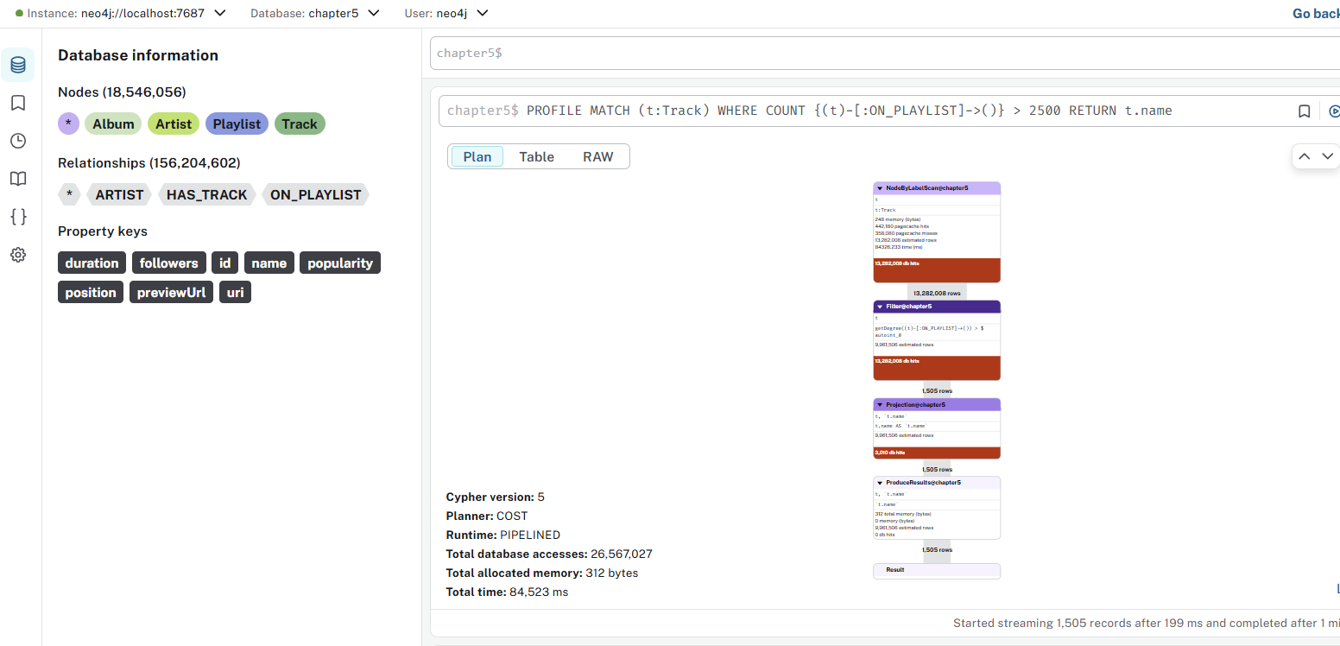

What this query actually does
Step 1️⃣ — MATCH (t:Track)
- This retrieves every Track node first.
- If you have 100 K+ tracks, it starts with all of them.
Step 2️⃣ — COUNT { (t)-[:ON_PLAYLIST]->() }
- For each track, Neo4j counts how many :ON_PLAYLIST relationships exist.
- This is still a full traversal per track — same amount of work as before, just written in a more elegant form.
Step 3️⃣ — WHERE … > 2500
- The filtering happens after the inner count for each track.
- So you still do potentially millions of small expansions (one per track).

Why it still runs long
Cause | Explanation
High track count | Each Track node must evaluate its outgoing :ON_PLAYLIST count.
No index use | The pattern count { … } cannot use relationship indexes (they don’t exist in Neo4j).
Late pruning | The > 2500 filter only removes results after counting them.
So if you have, say, 50 000 tracks, and each connects to hundreds or thousands of playlists, Neo4j still touches millions of relationships.

Ways to optimize
✅ 1️⃣ Use LIMIT for diagnostics
PROFILE
MATCH (t:Track)
WHERE COUNT { (t)-[:ON_PLAYLIST]->() } > 2500
RETURN t.name
LIMIT 10
If this runs much faster, you’re dealing with dataset scale, not logic.

✅ 2️⃣ Filter Tracks first (if possible)
If you can filter by artist, genre, year, or property — do it before counting:
MATCH (t:Track)
WHERE t.year >= 2020
AND COUNT { (t)-[:ON_PLAYLIST]->() } > 2500
RETURN t.name

✅ 3️⃣ Use EXPLAIN before PROFILE
EXPLAIN lets you see if the planner is using an index before committing time and memory to run the full query.

✅ 4️⃣ If this is a one-time analysis, use apoc.cypher.runTimeboxed to prevent runaway runtime
CALL apoc.cypher.runTimeboxed(
'MATCH (t:Track)
WHERE COUNT { (t)-[:ON_PLAYLIST]->() } > 2500
RETURN t.name',
{},
20000 // milliseconds (20 seconds)
)
YIELD value
RETURN value;

✅ 5️⃣ If you’ll query this often → precompute relationship counts
For analytical workloads, precompute a property like t.playlistCount and update it periodically:
MATCH (t:Track)
SET t.playlistCount = size([(t)-[:ON_PLAYLIST]->()])

Then your query becomes instant:
MATCH (t:Track)
WHERE t.playlistCount > 2500
RETURN t.name

020-degrees-3

chapter5$
EXPLAIN
MATCH (t:Track)
WHERE COUNT {(t)-[:ON_PLAYLIST]->(:Playlist)} > 2500
RETURN t.name

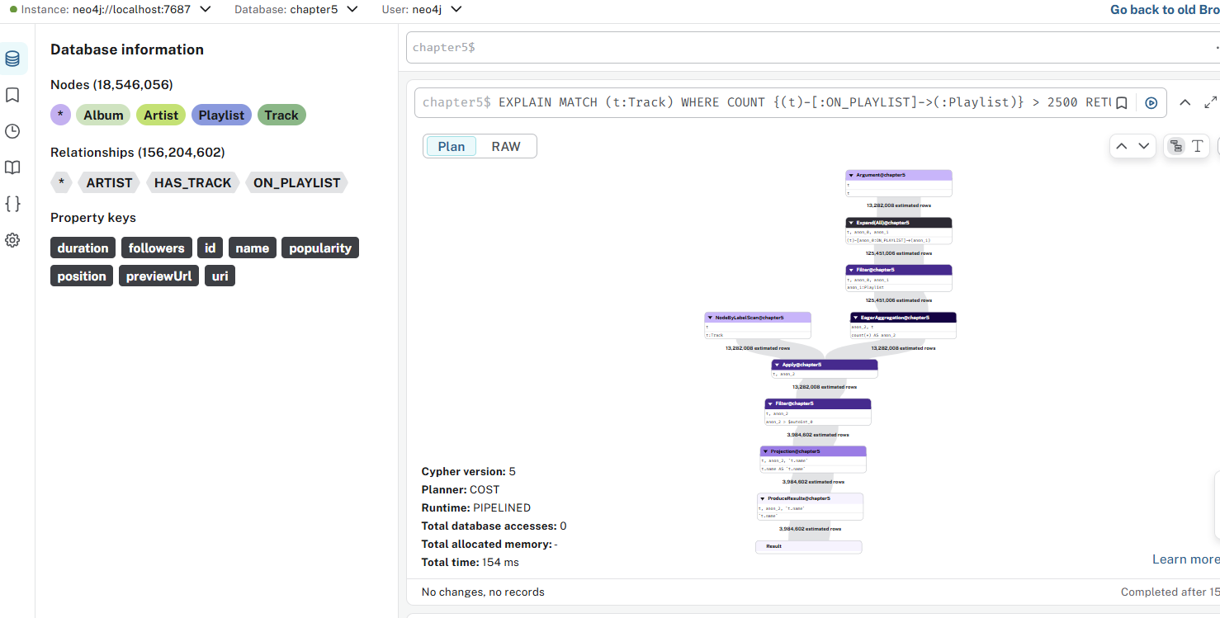

021-eager-1

chapter5$
EXPLAIN
MATCH (p:Playlist) WHERE p.followers = 100
DELETE p
MERGE (p2:Playlist) SET p2.followers = 100

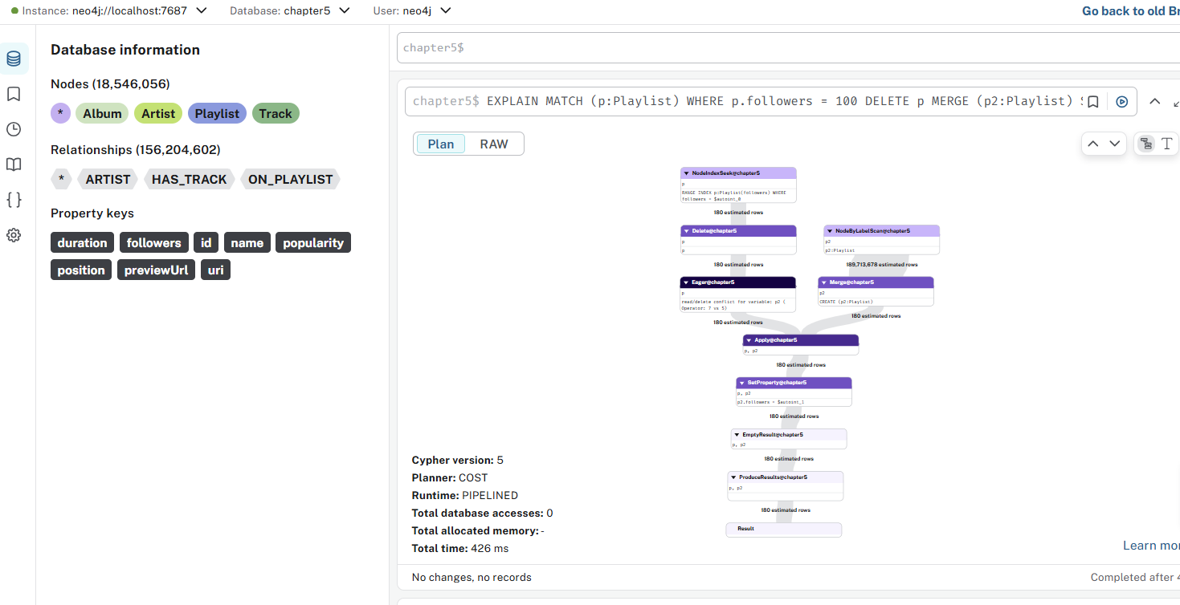

What Neo4j will show you
The EXPLAIN output will likely contain something like:
+----------------+-----------------------------------+
| Operator | Details |
+----------------+-----------------------------------+
| NodeByLabelScan| :Playlist |
| Filter | p.followers = 100 |
| Delete | p |
| Merge | (p2:Playlist) |
| SetProperty | p2.followers = 100 |
+----------------+-----------------------------------+

What actually happens (semantics)
- MATCH (p:Playlist) WHERE p.followers = 100
  - Finds every playlist with exactly 100 followers.
- DELETE p
  - Deletes each of those playlists from the database.
- MERGE (p2:Playlist)
  - This tries to find or create a Playlist node, but because you didn’t specify any match property, it just ensures at least one Playlist exists (and may reuse or create one depending on what was deleted).
  - If any Playlist node already exists, it uses it.
  - If none exist, it creates a new, anonymous one.
- SET p2.followers = 100
  - Sets that node’s followers property to 100.

❌ Logical issue
The MERGE clause doesn’t depend on the deleted nodes.
After DELETE p, all variables referring to deleted nodes (p) are gone, so the MERGE creates or reuses an unrelated node.
So effectively, your query:
- Deletes all Playlists with 100 followers,
- Then either reuses or creates one new Playlist and sets its followers to 100.
If your intention was to replace those deleted nodes with a single new one, it works; if not, it’s a bug.

Correct forms depending on your goal
👉 If you meant “delete duplicates, keep one node with 100 followers”:
MATCH (p:Playlist)
WHERE p.followers = 100
WITH collect(p) AS playlists
CALL {
WITH playlists
FOREACH (p IN playlists[1..] | DELETE p)
}
WITH playlists[0] AS one
SET one.followers = 100;

👉 If you meant “delete all, then create exactly one Playlist with 100 followers”:
MATCH (p:Playlist) WHERE p.followers = 100
DELETE p
CREATE (p2:Playlist {followers: 100});

👉 If you meant “update existing or create if none exist”:
MERGE (p:Playlist {followers: 100});

022-eager-2

chapter5$

EXPLAIN
MATCH (t:Track)-[:ARTIST]->(a:Artist)
RETURN a.name as artistName, avg(t.duration) as avgDuration
ORDER BY avgDuration

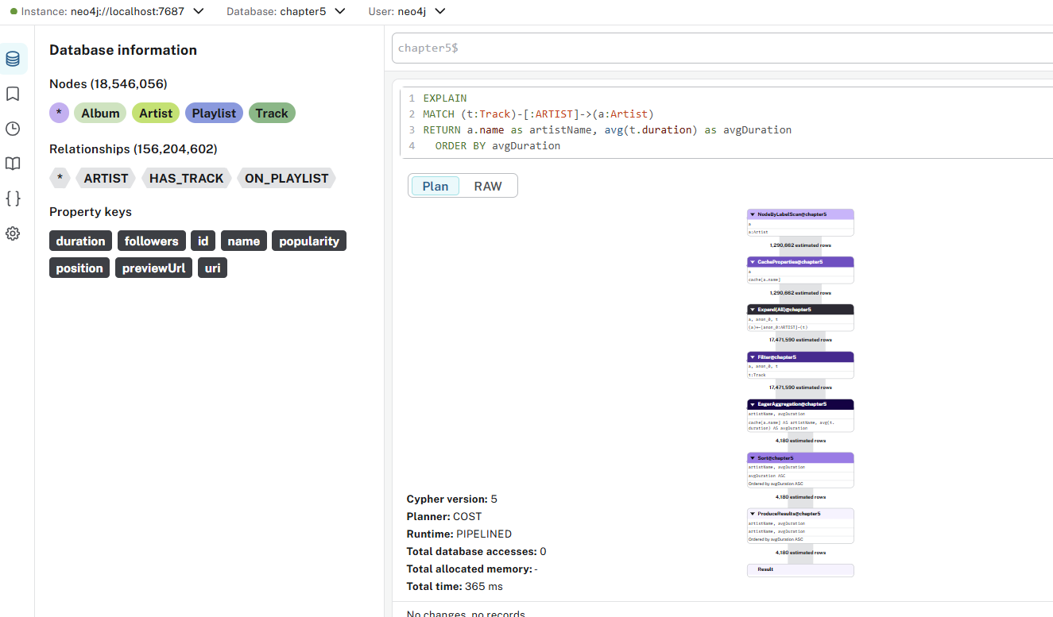

Possible performance bottlenecks
Issue | Explanation
Full label scan on :Track | No WHERE clause → reads all tracks.
No index use | Indexes only help when filtering or matching by property, not for pure aggregation.
Large intermediate data | If the graph has many tracks, the aggregation operator handles lots of input rows.
Sorting step | Sorting all artists by avgDuration can add noticeable time on large result sets.

Optimizing tips
✅ 1. Filter early if possible
Example:
MATCH (t:Track)-[:ARTIST]->(a:Artist)
WHERE t.year >= 2020
RETURN a.name AS artistName, avg(t.duration) AS avgDuration
ORDER BY avgDuration;
→ Fewer tracks scanned → faster aggregation.

✅ 2. If t.duration is missing sometimes
Ensure the property exists or coalesce:
RETURN a.name, avg(coalesce(t.duration, 0)) AS avgDuration

✅ 3. Limit or skip sorting cost
If you only want top or bottom N:
RETURN a.name, avg(t.duration) AS avgDuration
ORDER BY avgDuration DESC
LIMIT 10;

✅ 4. If this query is common
Precompute the average once per artist and store it:
MATCH (a:Artist)<-[:ARTIST]-(t:Track)
WITH a, avg(t.duration) AS avgDur
SET a.avgDuration = avgDur;
Then:
MATCH (a:Artist)
RETURN a.name, a.avgDuration
ORDER BY a.avgDuration;
→ Near-instant results for repeated use.

023-sorting-1

chapter5$
EXPLAIN
MATCH (a:Artist)<-[:ARTIST]-(t:Track)
RETURN a.name as artistName, t.duration as trackDuration
ORDER BY trackDuration

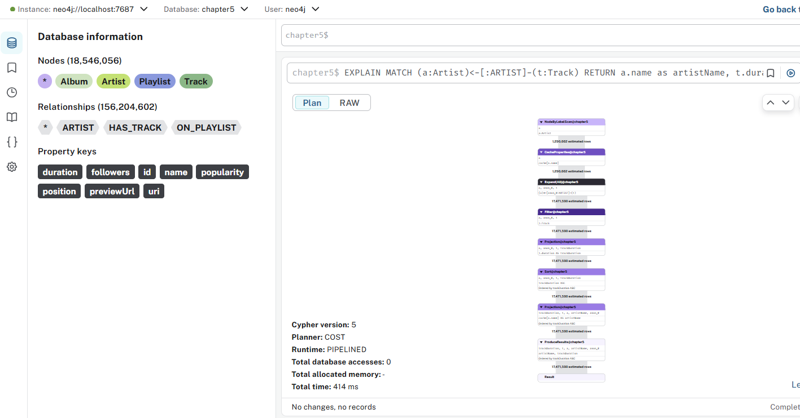

🚀 Optimization Tips
✅ 1. Add a filter to reduce data volume
If you only care about recent tracks or a duration range:
MATCH (a:Artist)<-[:ARTIST]-(t:Track)
WHERE t.duration IS NOT NULL AND t.duration > 60
RETURN a.name, t.duration
ORDER BY t.duration

✅ 2. Limit the output early
If you only need the top/bottom few:
MATCH (a:Artist)<-[:ARTIST]-(t:Track)
RETURN a.name, t.duration
ORDER BY t.duration DESC
LIMIT 20;
→ LIMIT dramatically reduces sort cost (uses partial sort internally).

✅ 3. Use an index (if duration filtering)
If you filter by duration often:
CREATE INDEX track_duration_index FOR (t:Track) ON (t.duration);
→ This doesn’t speed up sorting directly, but helps when combined with WHERE.

✅ 4. Pre-store derived data if repeatedly sorted
If your analysis often sorts by duration or similar numeric fields, precompute top tracks once and store them.

024-sorting-2

EXPLAIN
MATCH (a:Artist)<-[:ARTIST]-(t:Track)
RETURN a.name as artistName, t.duration as trackDuration
ORDER BY trackDuration LIMIT 5

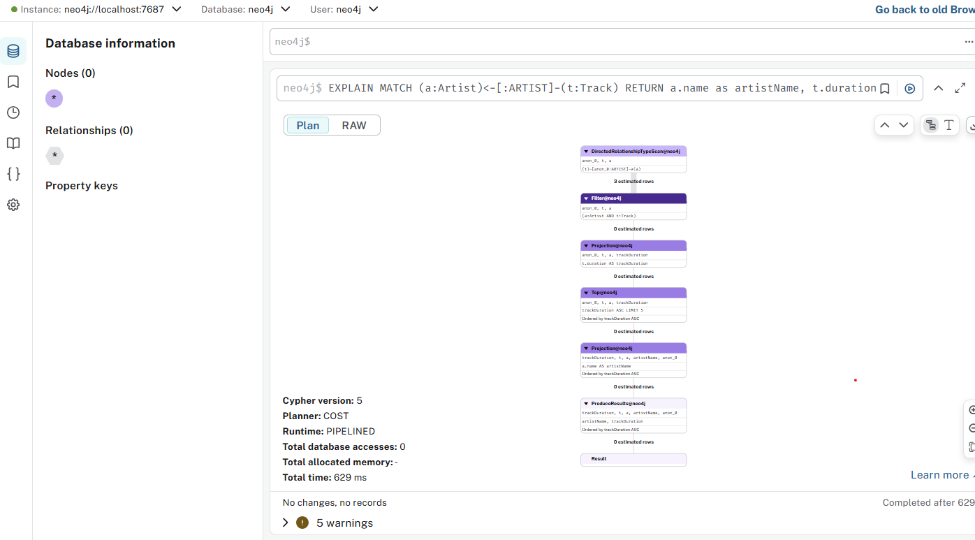

🔍 What the Execution Plan Looks Like
Neo4j will show something like:
+-------------------------------------------------------+
| Operator | Details |
+-------------------------------------------------------+
| NodeByLabelScan | :Track |
| Expand(All) | (t)-[:ARTIST]->(a) |
| Projection | a.name, t.duration |
| Top | ORDER BY trackDuration, 5 rows |
| ProduceResults | ... |
+-------------------------------------------------------+

🚀 Key Point — LIMIT turns SORT into TOP
When you add:
ORDER BY trackDuration LIMIT 5
Neo4j does NOT perform a full global sort.
Instead, it uses the Top operator (a partial sort):
✔️ It keeps only the best 5 rows in memory.
✔️ It does NOT sort the entire result set.
✔️ O(n) behavior instead of O(n log n). Much faster.

025-sorting-3

CREATE INDEX track_duration FOR (n:Track) ON (n.duration)

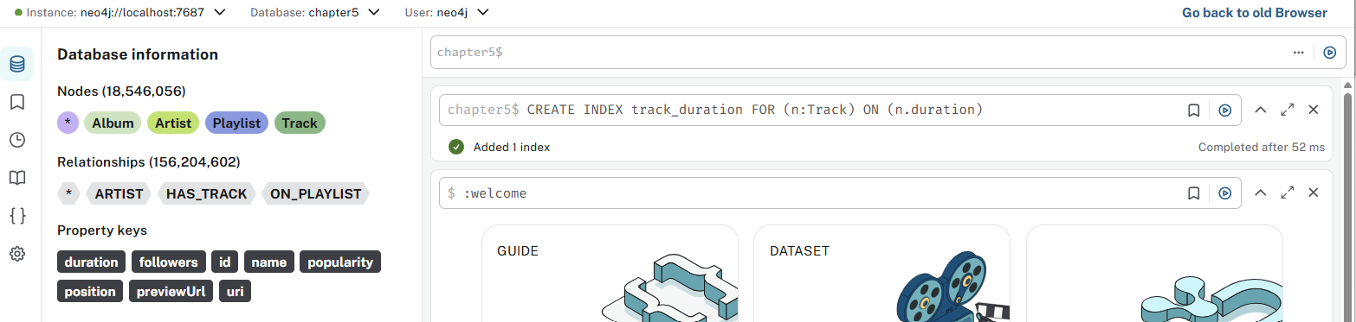

This creates a range index on the property Track.duration.

🔍 What this index is good for
✔️ 1. Filtering using the property
The index speeds up WHERE filters, e.g.:
MATCH (t:Track)
WHERE t.duration > 200000
RETURN t
or
MATCH (t:Track)
WHERE t.duration = 180000
RETURN t
Neo4j then uses IndexSeek instead of scanning all Tracks.

🚫 What this index is NOT good for
❌ It CANNOT optimize your query:
MATCH (a:Artist)<-[:ARTIST]-(t:Track)
RETURN a.name, t.duration
ORDER BY t.duration
LIMIT 5
Reason:
Neo4j cannot ORDER BY using an index when the query also requires:
- Scanning relationships ((t)-[:ARTIST]->(a))
- Returning values from both sides

🧠 Why the index is not used for ORDER BY in this pattern
Neo4j can only use the index for ordering if the index is the starting point of the query.
Example where the index would be used for ordering:
MATCH (t:Track)
RETURN t.duration
ORDER BY t.duration
LIMIT 5
But when you do:
MATCH (t:Track)-[:ARTIST]->(a)
Neo4j must:
- Find all Track nodes
- Traverse relationships
- Then order the results
The index cannot maintain sorted order through a relationship traversal, so Neo4j falls back to:
- full scan (or index seek without order)
- then Top operator (because of LIMIT)

👍 When this index WILL be used
Example 1 — Filtering:
MATCH (t:Track)
WHERE t.duration < 120000
RETURN t.name
Example 2 — Range queries:
MATCH (t:Track)
WHERE t.duration >= 100000 AND t.duration <= 200000
RETURN t
Example 3 — Exact lookups:
MATCH (t:Track {duration: 180000})
RETURN t

⚡ Recommend: create an index for your filtering queries
If you often run:
WHERE COUNT {(t)-[:ON_PLAYLIST]->()} > 2500
You need a relationship index (called relationship existence index) or a precomputed property.

026-sorting-4

EXPLAIN
MATCH (a:Artist)<-[:ARTIST]-(t:Track)
WHERE t.duration > 0
RETURN a.name as artistName, t.duration as trackDuration
ORDER BY trackDuration

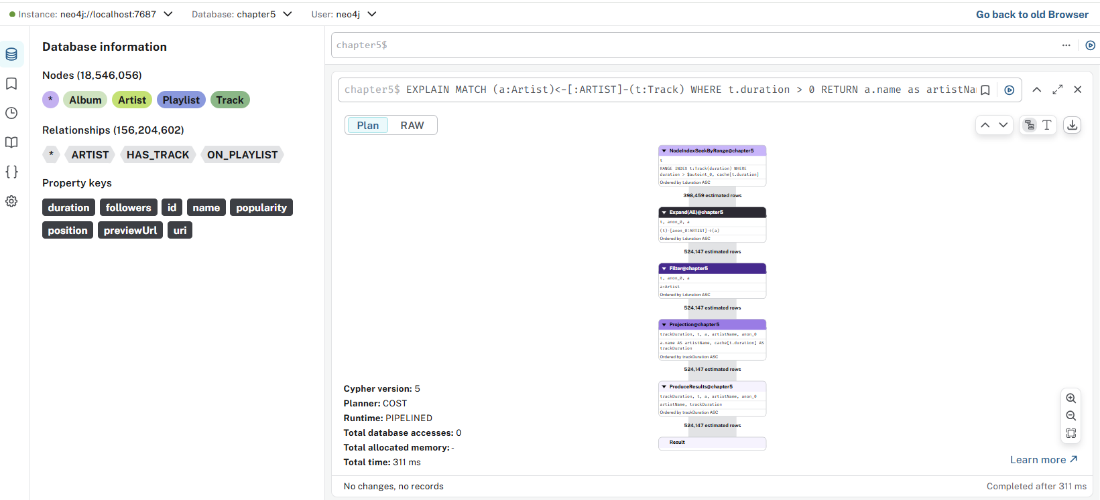

Here is exactly what this query does, how the planner behaves, and why the index STILL will not be used for ordering even though you added:
CREATE INDEX track_duration FOR (n:Track) ON (n.duration)

🔍 1. Will the index be used for the WHERE t.duration > 0 filter?
✔️ YES
Neo4j will likely use it as a Range Index Seek, because t.duration > 0 is a perfect case for a range index.
So your plan will look like:
NodeIndexScan ( TRACK on duration > 0 )
→ Expand into (Artist)
→ Sort
BUT…

